**Weekly Report – W16 Fall 2022**

**Problem & Task**

1. Last week to examine the dynamic process of the SRA for the package “TMTDyn”, I modified the force exerting on the tip of the SRA, just in x direction, however, more tests need to be performed to verify its dynamics, for example, by applying forces on y and z axis respectively;
2. We have confirmed that the dataset “z” represents the final results (storing the intermediate variables), and by increasing each link/segment, there will be another 12 variables emerged, but what they stand for remains unknown; and when they have been clarified, the DoF for each link will be confirmed as well;
3. Clarify if there is any pressure or force limit for the usage of the real SRA and the simulation.

**Solution**

1. Dynamic process verification for y and z direction

Since in the example file provided by the author of the package, there are some physical experiments to record the position change of the SRA tip, which could be used to make a comparison between the simulation results under the same force or torque inputs, however, the physical experimental data would not change no matter for what kind of input we set, and the original experimental will always be displayed which could cause a lot confusion to other readers or users haven’t utilized this package ever before. Therefore, apart from doing the additional tests for y and z axis, I also need to think about a way to erase the original physical experimental data from the final plots. It turned out that I could only erase the physical experimental results in the input figure, for the position record figure, I still have to work on it.

The results of the tests performed on y axis are shown as below.

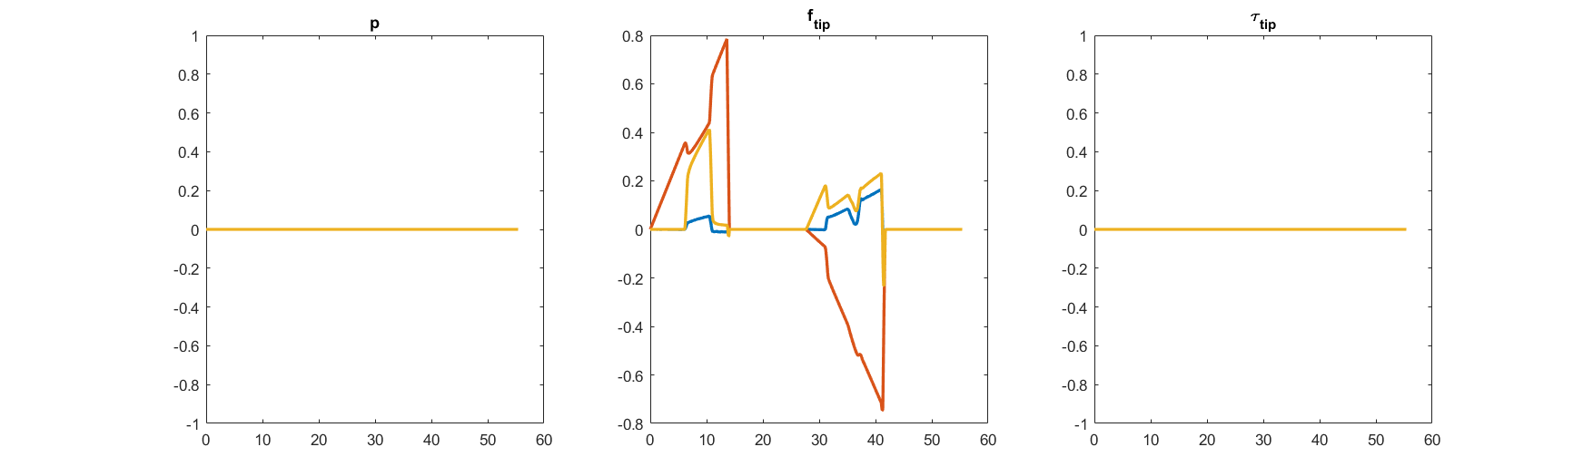

**Fig. W16-1** The input with force exerted on y axis direction only (Max 0.8N)

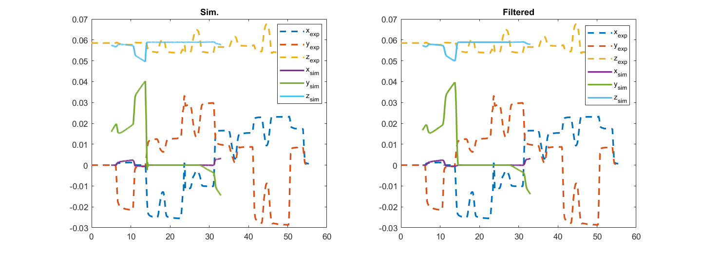

**Fig. W16-2** The position record of the SRA tip under the force exerted on the y axis direction only

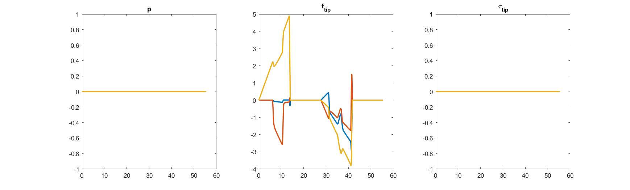

**Fig. W16-3** The input with force exerted on z axis direction only (Max 5N)

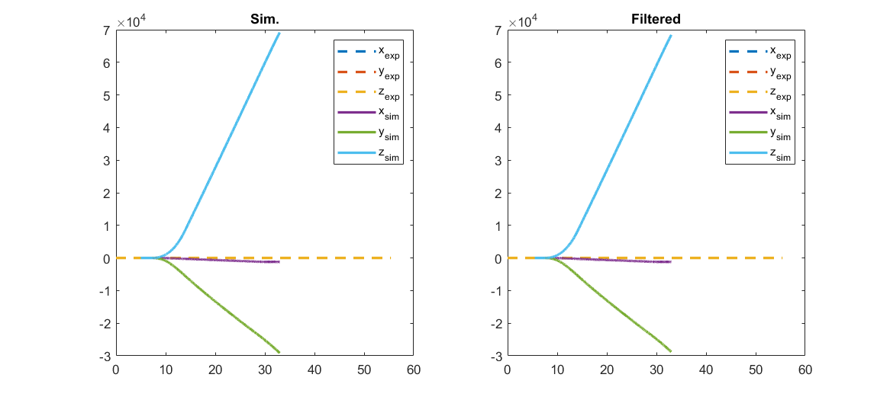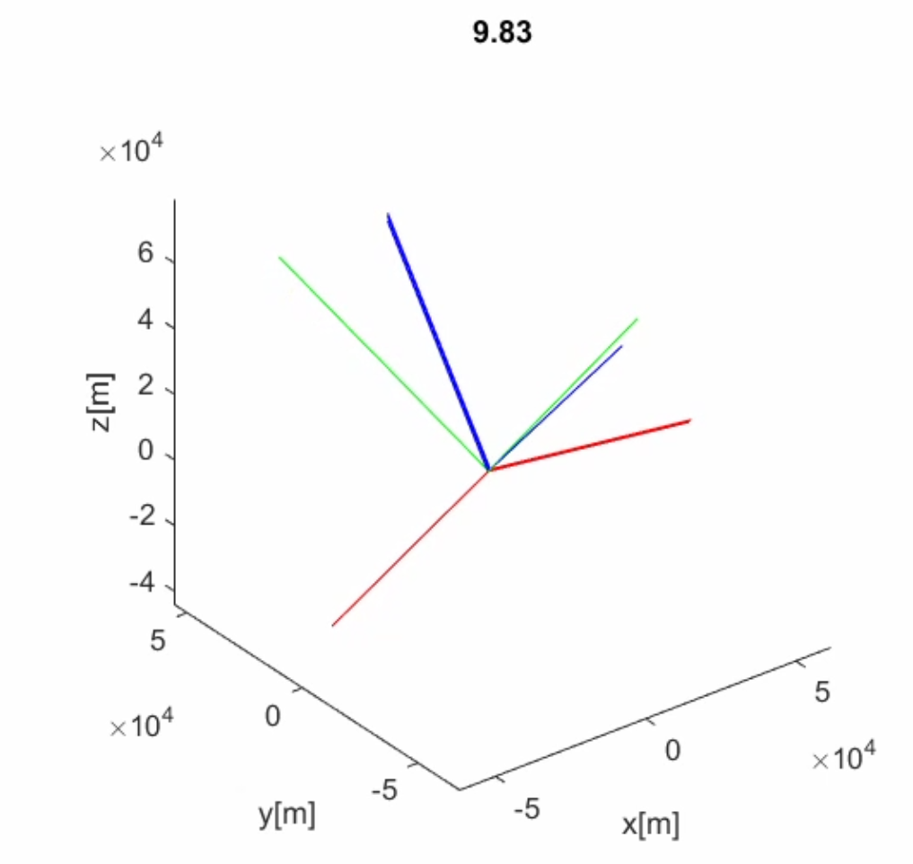

**Fig. W16-4** The position record of the SRA tip under the force exerted on the z axis direction only

We can see that the simulation position of the SRA tip under the force exerted on the y direction only performed normally, however, for z direction, it performed in an odd manner maybe because the force applied is too large causing the animation crack. Then I set the maximum force on z direction to be 1 N, then it led to a perfect simulation result shown below.

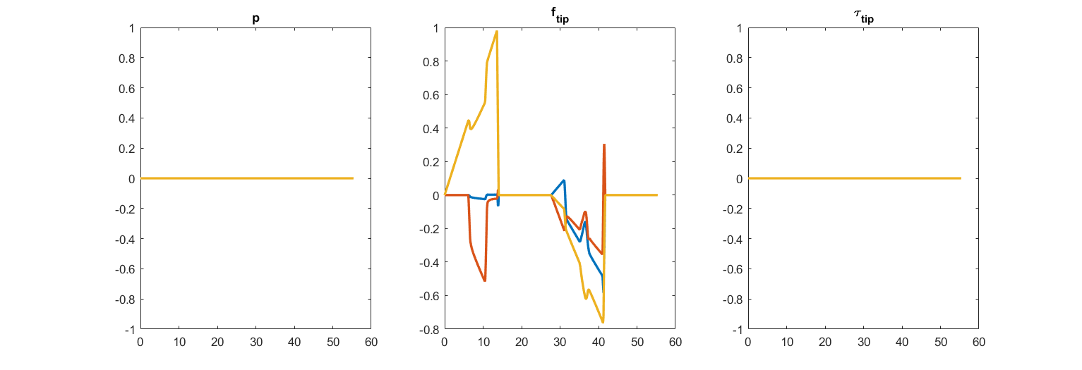

**Fig. W16-5** The input with force exerted on z axis direction only (Max 1N)

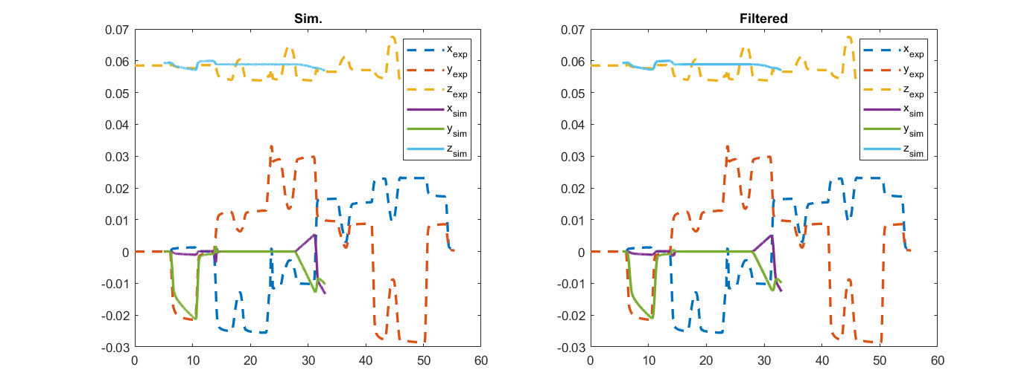

**Fig. W16-6** The position record of the SRA tip under the force exerted on the z axis direction only

1. DoFs for each SRA segment/link

To identify what each intermediate parameter stands for, we have basically two methods, one is to look up if there is any useful information introduced in the paper published by the author, and the other is to check the package’s code about definitions of each DoF. The investigation results are shown as follows.

(1). From the paper and by contacting with the author

As shown in the figure below, the author has stated that for each segment/link/joint, there will be 3 DoF correspondingly, which are on axial elongation and two side bendings. However, the DoF was defined to be 6 times of the number of segment/link/joint, which is ambivalent to his descriptions about this table.

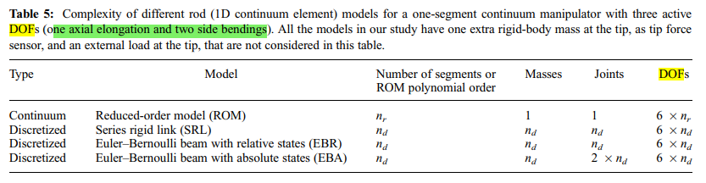

**Fig. W16-7** The screen shot of the description of DoF for different modelling methods in the paper of TMTDyn package’s author

To clarify this issue, I have tried to contact the author by email (he is still in King’s College of London), but he hasn’t replied me yet; and I have no choice but to follow him on Twitter, and sent him a private message to ask if I could have his contact for further discussion about utilization of the package, still no response.

(2). From the code

So I have to turn back to the code itself, in the main function of exp2_EBR.m, I found that the DoFs were defined in two classifications, the effects by force and torque. The proof is shown as follows,

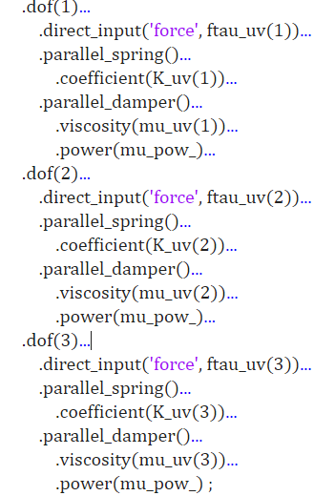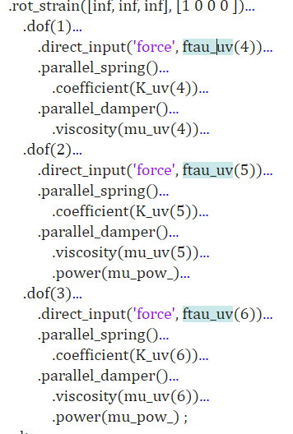

**Fig. W16-8** The screen shots of the definitions about DoF for EBR modelling

From the code, we can deduct that all the forces and torques no matter in what directions, are stored in the array (or row vector) ftau_uv, which was defined as follows,

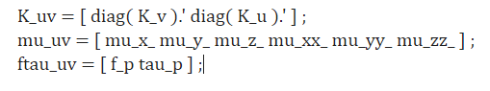

**Fig. W16-9** The definition of variable ftau_uv in the main function of the package

So obviously ftau_uv is a row vector with size , the first three elements are the forces directly exerted on the SRA tip and the rest are the torques.

1. Pressure & force limit for the SRA

The author hasn’t covered any information about it, the only commercial device I can search online is the compressor, BAMBI MD Range Model 150/500, some basic specifications are shown as follows,

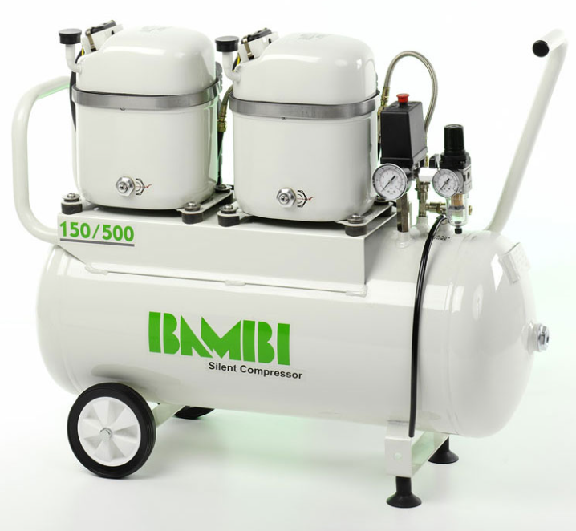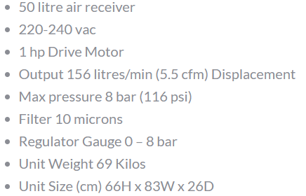

**Fig. W16-10** The basic specifications of the compressor used in the paper

**Plan**

1. If we still want to make sure that what each DoF stands for, I think we should not focus on the paper published by the author of the package any more, since there is no further information about DoF; so I plan to investigate other potential papers which used the same implement, the STIFF-FLOP continuum appendage to find if there is something helpful for us to understand the code.